NET ZERO PROGRESS
At Home Farm Cranmer we’ve planted over 26,000 hedge plants, that's over 2.5 miles of new hedges and over 1,250 trees since arriving at Home Farm 23 years ago.
Our biomass boiler has delivered 3067900 kWh of energy
for heating and hot water to our pool cottages & facilities.
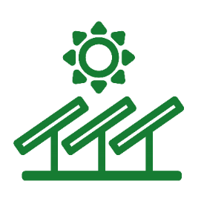
Our solar PV and solar thermal arrays have produced over 3068 kWh of green electricity for heating and hot water for use in our holiday cottages and onsite facilities at Cranmer Country Cottages.
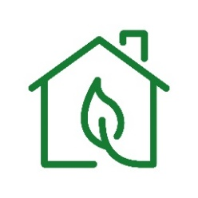
Our Ground source heat pump has produced 257370 kWh & provides space heating for the Eco Barns, in the form of underfloor heating. Utilising electricity supplied by solar PV and supplemented by Ecotricity.
Our wind turbine has produced 209324 kWh of green electricity since 2010 – when the sun doesn’t shine at night the wind often blows!

Our LED lighting, installed throughout our site will save us over 2.6 tonnes of Co2 per year! That’s equivalent to 2.5 x 500m3 hot air balloons!
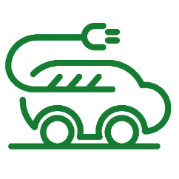
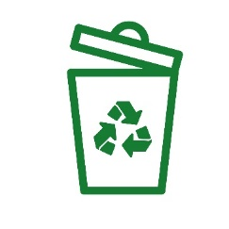
In 2022-23 our Electric Vehicle charge points have supplied 2545 kWh of green electricity for electric and hybrid cars or 10,180 low-emission miles. (Typically an EV will travel 4miles/kWh

Since 2015 we have reduced the amount of waste we send to landfill by over 40%. There is more we can do by encouraging our guests to help us maintain reduce, recycle, reuse waste streams during their stay.

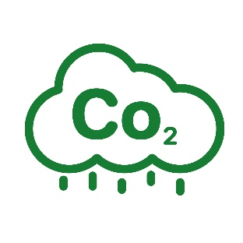
So far we can demonstrate a net saving of over 420 tonnes of Co2 between 2008 -2019, with further reduction between 2019 – 2023. That’s equivalent to over 420 x 500m3 hot air balloons! (= 1 tonne Co2)

